Trip to Vern d’Anjou 2010

On Friday 2nd April, 35 villagers (some regulars and some new ‘Twinners’ and 2 more who cycled across) set out at 5am on a long but incredibly smooth coach journey thanks to our fantastic driver Billy from Skinners, who made it feel like we were on a smooth train! There was a buzz of excitement mixed with apprehension and anticipation. It is always a little nerve racking wondering who you will be hosted by and how much English they speak, but the people of Vern are SO friendly the worrying is entirely unnecessary.
After a warm welcome reception we were entertained by our hosts at home giving us the opportunity to get to know them over a meal. On Saturday we braved the wintery chill to visit the chateau of Breze near Saumur. It began as a subterranean or troglodyte dwelling created for defense in the early 11th century, with corridors so narrow as to make it impossible to wield a weapon. The castle itself is encircled by an impressive gorge-like 18 metre dry moat with immense galleries and chambers dug into the walls. One of these housed silk worms in niches in the walls, where we learnt that it takes 150 silk worms to make a silk tie! Others were used as an ice house, a bakery and, of course, to store the wines which are considered to be amongst the best in France.
Naturally we had to sample a few and in true English fashion we failed to wine ‘taste’ instead preferring to drink it! Well we do hate waste! With the weather closing in, we took shelter for a picnic lunch in a massive 16th century dovecote which had 3700 niches. Pigeons were a reliable form of communication as well as for food and eggs. Thankfully the birds were absent otherwise we might have had more than mayonnaise in our French bread!
After lunch, we toured the open wing of the chateau (the rest is still inhabited) before succumbing to the effects of the wine by snoozing on the return journey. We were entertained in the evening at the school restaurant with a dinner and dance.
Sunday morning we went to school! They have recently extended their primary school (sounds familiar) so we were proudly shown the new facilities which were very charming and included ‘La maternelle’, a room full of baby bear sized beds for the 3 year olds to sleep in. We were greeted with posters the children had drawn for us, welcoming us to Vern and wishing us a Happy Easter. They are keen to foster close relationships between the schools, something which Sue White has already established but progress is hampered slightly by the lack of IT in the class rooms.

Before lunch, an official reception was held in the Town Hall with speeches given by both French and English ‘Presidents’ as well as the Mayor. Several French families then hosted a leisurely lunch before convening for yet more wine-tasting in the village ‘cave’.
After dinner in the school restaurant our hosts projected a new ‘Just Dance’ Wii game onto the wall and before long everyone across all generations were up dancing. It was a real success and we were glad to work off some of the excesses!
On Monday morning, blessed with some sunshine, we took a guided walk around a slate mine which was surprisingly picturesque. We then watched a ‘splitter’ demonstrate how to split the slate down to 3mm thick before trimming into slate tiles. For lunch, we had a gastronomic picnic in a wooded glade before looking around the museum and watching (or snoozing!) through a short film.
The weekend culminated in a grand finale at ‘Le pigeon blanc’, the local restaurant in Vern that has been commended in the Michelin guide. The food was beautifully presented and extremely delicious. With accompanying band and more wine, our hosts joie de vivre was infectious resulting in much dancing around the tables!
If you’ve never been to Vern before, I would encourage you to take that leap of faith. You will be guaranteed a brilliant time and a cheap one at that! If going seems a bit of a big step then why not consider hosting next Easter? There really are few times you will be spending on your own with them. Often families get together for the meals to make the socialising easier all round.
It is difficult to convey the extent of the welcome they always give us. Perhaps the following quotes which we gathered on the way home speak for themselves.

Rosie Fuller

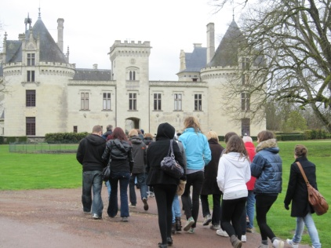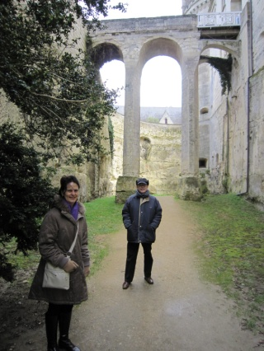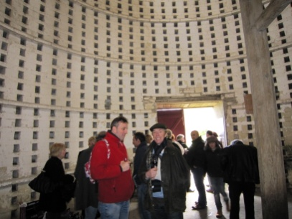

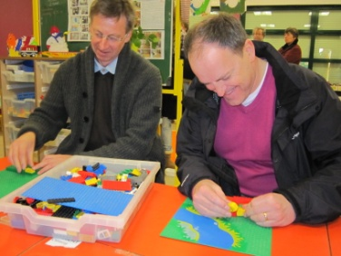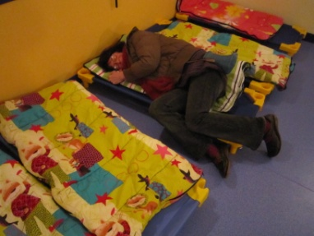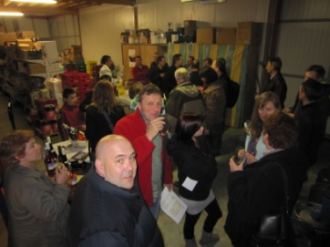

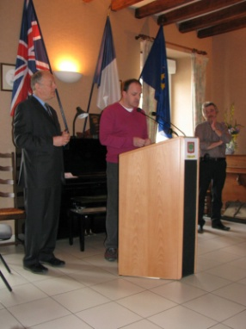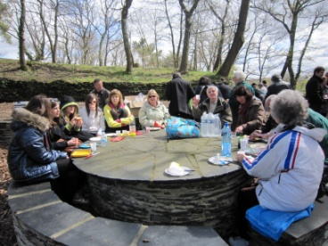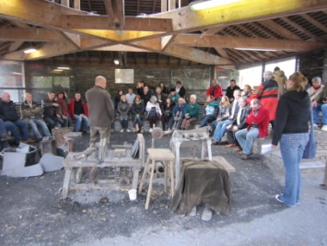

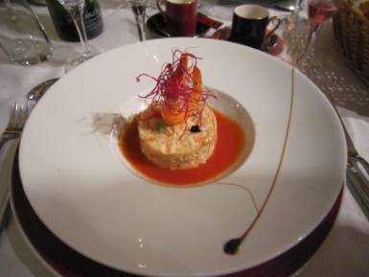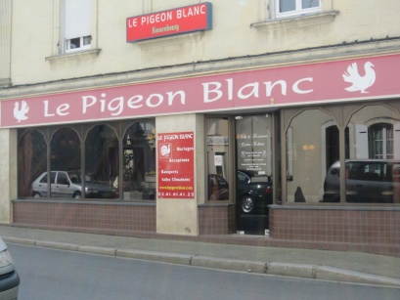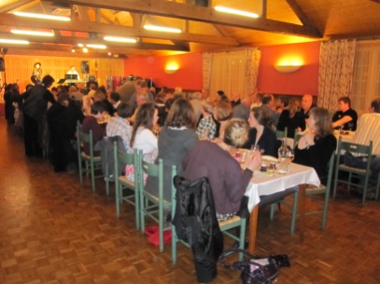

“Our collective ability to have fun together never ceases to amaze me and underpins why the jumelage (twinning) is so important. Not only does it continue to foster real relationships between two villages, it also deepens friendships already made. Everyone should try it – it certainly has enriched my life.”
Huw Davies
“My eyes are burning from the lack of sleep but my heart is full of warmth. It’s a unique experience to come to Vern and it gets richer as friendships develop. Lovely Vern people, lovely Tatsfield people”
Alizon Mooney
“Life is for living and our French friends certainly know how to live – such lovely laid back life – many thanks to everyone for a great weekend. Such hospitality and kindness – looking forward to hosting next year and returning the favour. I will try and brush us on the lingo now!”
Sue Ashmore
“What an amazing relationship we have! Long may it last. A holiday with the residents of Vern is something you can’t buy from the travel agents. It is a home from home. Merci beaucoup!”
Sue and John White

“A wonderful chance to meet up with long time French friends, and make new ones. Never a spare moment as usual, and such interesting trips, and fantastic meals. Everyone is given such a warm welcome. “
Rosemary and David Brown

“The French families showed us such great hospitality and I really felt immersed in the French spirit! Really good fun and definitely an exhaustingly exciting weekend! Thank you Frenchies!”
Jay White (16)

